**Ideation Phase**

**Define the Problem Statements**

|  |  |
| --- | --- |
| Date | 04 October 2022 |
| Team ID | PNT2022TMID |
| Project Name | Project – News tracker application |
| Maximum Marks | 2 Marks |

**Problem Statement:**

There are multiple news-sharing apps used by a single user and are often spammed with notifications. There is also a lot of fake news which gets shared. A news-sharing app wants to help users find relevant and important news easily every day and also understand explicitly that the news is not fake but from proper sources.

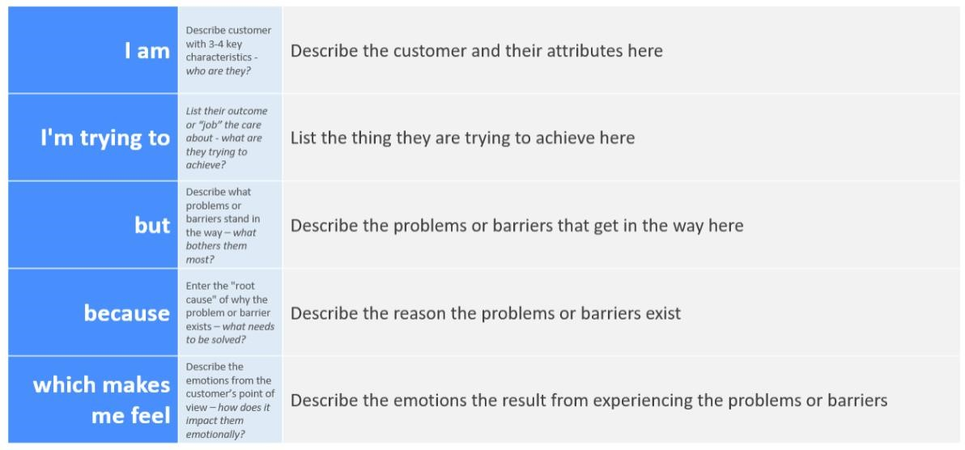**:** 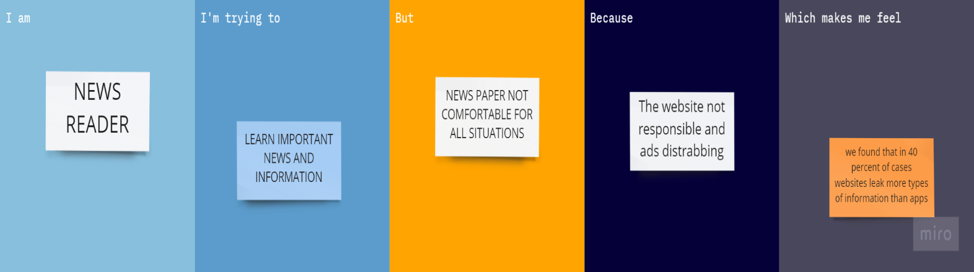

|  |  |  |  |  |  |
| --- | --- | --- | --- | --- | --- |
| **Problem**  **Statement (PS)** | **I am**  **(Customer)** | **I’m trying to** | **But** | **Because** | **Which makes me feel** |
| PS-1 | News reader | Learn important news and information | News paper not comfortable for all situation | The website not responsible and ads disturbing | We found that in 40 percentage of cases websites leak more types of information than apps |
| PS-2 | Business man | Learn about share market news | News pages shows unwanted news to them | Some fake news and ads | In news tracker application un wanted news are not show to them |